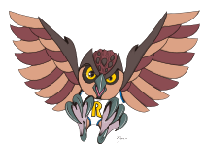  
**RIVERSIDE SCHOOL**

**2023-2024 SCHOOL SUPPLY LIST**

**FIRST GRADE**

|  |  |
| --- | --- |
| **Quantity** | **School Supply** |
| 10 | Large Glue Sticks |
| 1 | Child Scissors-ROUNDED TIP (labeled with name) |
| 2 | 24 count box of Crayola crayons |
| 2 | Thick yellow highlighters |
| 1 | Pencil sharpener with cap |
| 6 | Expo markers (black) |
| 2 | Large pink erasers |
| 24 | #2 sharpened pencils |
| 1 | Clipboard (labeled with name) |
| 1 | Headphones (labeled with name in a Ziplock bag) |
| 2 | Box of Kleenex |
| 2 | Containers of antibacterial wipes (example Clorox, Lysol) |
| 1 | Box of gallon bags (boys only) |
| 1 | Box of resealable sandwich bags (girls only) |
| 1 | Heavy duty take-home folder |
| 1 | Container of playdoh (any color) |